MH10.8.8 – 2006



Radio Frequency Identification for
Packages, Parcels, and Flat Mail

Approved: 19 May 2006

Abstract
This standard provides guidance for the use of radio-frequency identification (RFID) for the handling and tracking of packages, parcels, and flat mail. The standard identifies minimum data requirements as well as semantic and syntactical recommendations. This standard further provides specific recommendations for the air interface communications of RFID devices based on the application requirements identified by the carriers.

Developed by:

MH10 Committee, Unit-Loads and Transport-Packages

Published by MH10 Secretariat:

Material Handling Industry
8720 Red Oak Blvd., Suite 201
Charlotte, NC 28217-3992
standards@mhia.org



American National Standard

Approval of an American National Standard requires verification by ANSI that the requirements for due process, consensus, and other criteria for approval have been met by the standards developer.

Consensus is established when, in the judgement of the ANSI Board of Standards Review, substantial agreement has been reached by directly and materially affected interests. Substantial agreement means much more than a simple majority, but not necessarily unanimity. Consensus requires that all views and objections be considered, and that a concerted effort be made toward their resolution.

The use of American National Standards is completely voluntary; their existence does not in any respect preclude anyone, whether he has approved the standards or not, from manufacturing, marketing, purchasing, or using products, processes or procedures not conforming to the standards.

The American National Standards Institute does not develop standards and will in no circumstances give an interpretation of any American National Standard. Moreover, no person shall have the right or authority to issue an interpretation of an American National Standard in the name of the American National Standards Institute. Requests for interpretations should be addressed to the sponsor whose name appears on the title page of this standard.

CAUTION NOTICE: This American National Standard may be revised or withdrawn at any time. The procedures of the American National Standards Institute require that action be taken periodically to reaffirm, revise or withdraw this standard. Purchasers of American National Standards may receive current information on all standards by calling or writing the American National Standards Institute.

Copyright© 2006 by Material Handling Industry
All rights reserved.

No part of this publication may be reproduced in any form,
in an electronic retrieval system or otherwise, without
prior written permission of the Materials Handling Industry,
MH10 Secretariat, 8720 Red Oak Blvd., Suite 201, Charlotte, NC 28217-3992
Phone: 704-676-1190, Fax: 704-676-1199
Email: mhstandards@mhia.org

Printed in the United States of America.

ANSI MH10.8.8 – 2006

American National Standard

Radio Frequency Identification for
Packages, Parcels, and Flat Mail

Developed by:

MH10 Committee, Unit-Loads and Transport-Packages

Published by MH10 Secretariat:

Material Handling Industry
8720 Red Oak Blvd., Suite 201
Charlotte, NC 28217

Approved May 19, 2006
American National Standards Institute, Inc.

Disclaimer

This standard, which was developed under the ANSI Committee method and approved by ANSI on 19 May 2006, represents suggested design practices and guidance for the marking of product packaging with linear bar code and two-dimensional symbols. It was developed with the sole intent of offering information to parties engaged in the manufacture, marketing, purchase, or use of automatic identification equipment software and services. This standard is advisory only and acceptance is voluntary and the standard should be regarded as a guide that the user may or may not choose to adopt, modify, or reject. The information does not constitute a comprehensive safety program and should not be relied upon as such. Such a program should be developed and an independent safety adviser consulted to do so.

Material Handling Industry (MHI), the MH10 Committee and its officers and members assume no responsibility and disclaim all liability of any kind, however arising, as a result of acceptance or use or alleged use of this standard. User specifically understands and agrees that MHI, the MH10 Committee and their officers, committee members, agents, and members shall not be liable under any legal theory of any kind for any action or failure to act with respect to the design, installation, manufacture, preparation for sale, sale, characteristics, features, or delivery of anything covered by this standard. Any use of this information must be determined by the user to be in accordance with applicable federal, state, and local laws and regulations.

MHI, the MH10 Committee and its officers and members make no warranties of any kind, express, implied, or statutory, in connection with the information in this standard. MHI and the MH10 Committee specifically disclaim all implied warranties of merchantability or of fitness for particular purpose.

By referring to or otherwise employing this standard, the user agrees to defend, protect, indemnify, and hold MHI, the MH10 Committee, their officers, committee members, agents, and members harmless from and against all claims, losses, expenses, damages, and liabilities, direct, incidental, or consequential, arising from acceptance or use or alleged use of this standard, including loss of profits and reasonable attorneys' fees which may arise out of the acceptance or use or alleged use of this standard. The intent of this provision and of the user is to absolve and protect MHI, the MH10 Committee, their officers, committee members, agents, and members from any and all loss relating in any way to this standard, including those resulting from the user's own negligence.
Foreword (This foreword is not part of American National Standard MH10.8.8-2006)

Increasingly, commercial and government letter, parcel, and small package carriers are finding needs to have interoperable methods of handling, processing, and tracking of items sent through postal and logistics services. Many industries have adopted the framework of a specific standard, American National Standards (ANS) MH10.8.1, in their implementation of shipper-to-consignee information with respect to optically readable media. This standard addresses the carrier implementation of the MH 10/SC8 standards while expanding the applications to radio frequency identification.

Internationally, the ISO TC 122 (Packaging)/TC 104 (Freight Containers) Joint Working Group – Supply Chain Applications of RFID is addressing standards for product packages (ISO 17366) and transport units (ISO 17365). There is a close coordination between the efforts of the international community and the development of this standard.

At the time of approval, the MH10 Committee consisted of the following members:

AIM, Inc. Integrated Business Communications Alliance
American Trucking Associations Intermec Technologies
American Wood Packaging Association International Cargo Handling Coordination Association
APA – The Engineered Wood Association International Safe Transit Association
Association of American Railroads Material Handling Industry
Assoc. of Professional Material Handling Consultants Material Handling Management Society
Association of American Railroads National Wood Pallet & Container Association
ASTM Plastic Drum Institute
Automotive Industry Action Group Q.E.D. Systems
CompTIA Rack Manufacturers Institute
Containerization & Intermodal Institute, Inc. Reusable Industrial Packaging Association
Electronics Industries Association Steel Shipping Container Institute
Fibre Box Association Textile Bag Manufacturers Association
Flexible Intermediate Bulk Containers Association U.S. Dept. of Agriculture
Food Marketing Institute U.S. Dept. of Defense Logistics
Glass Packaging Institute U.S. Forest Products Laboratory
Graphic Communications Association Uniform Code Council
Industrial Metal Containers & Wire Decking (IMC&WD) United Fresh Fruit & Vegetable Association
Institute of Packaging Professionals United Parcel Service

At the date of approval of this standard, the MH10.8 Committee consisted of the following members:

AIAG High Tech Aid
Allied Labels and Ribbons IBM
ATA Intermec
Boeing Motorola
Bruno Associates QED Systems
Canada Post Strategic Consulting Services
CDO Telecordia Tech/ATIS BCSC
DLA Texas Instruments
DoD AIT Project Office Uniform Code Council
Federal Express UPS
General Motors USAF
Hand Held Products USPS

Suggestions for improvement, and questions regarding interpretation of this standard will be welcome. They should be sent to: MH 10 Committee (MHIA), Material Handling Industry of America, 8720 Red Oak Blvd., Suite 201, Charlotte, NC, 28217-3992 or mhstandards@mhia.org.

AMERICAN NATIONAL STANDARD ANSI MH10.8.8 – 2006

RADIO FREQUENCY IDENTIFICATION FOR PACKAGES,
PARCELS, AND FLAT MAIL

Table of Contents
1 Scope 1
2 Normative References 1
3 Terms and Definitions 2
3.1 carrier pickup. 3
3.2 container. 3
3.3 delivery. 3
3.4 delivery preparation. 3
3.5 dock operations. 3
3.6 flat. 3
3.7 flat mail (flat-size mail). 3
3.8 item. 3
3.9 label. 3
3.10 letter mail. 3
3.11 mail. 3
3.12 package. 3
3.13 packaging. 3
3.14 parcel. 3
3.15 pure URI. 3
3.16 sortation. 4
3.17 tag. 4
3.18 transport unit. 4
3.19 transport package. 4
3.20 transportation. 4
3.21 UII (Unique Item Identifier). 4
3.22 unit load (unitized load). 4
3.23 URI. 4
4 Application description(s) 4
4.1 Survey results. 4
4.2 How far. 4
4.3 How fast. 4
4.4 How much. 5
4.5 How many. 5
4.6 Environmental conditions. 5
4.7 General characteristics. 6
5 Technology Considerations 6
5.1 Antenna placement/design. 6
5.2 Frequency applicability 6

AMERICAN NATIONAL STANDARD ANSI MH10.8.8 – 2006

RADIO FREQUENCY IDENTIFICATION FOR PACKAGES,
PARCELS, AND FLAT MAIL

Table of Contents (continued)

6 Concepts 7
6.1 Principles 7
6.2 Unique identifier (UII) 8
6.3 Label formats 8
6.3.1 Base item label/tag 8
6.3.2 Extended mail piece label/tag 8
7 Data structure 9
7.1 Data 9
7.1.1 License plate application 9
7.1.2 Data rich application 9
7.2 Data presentation 9
7.2.1 Data semantics 9
7.2.2 Data syntax 9
7.2.3 Data in human readable forms 9
7.3 Data elements 9
7.3.1 Unique item identifier (UII) (Mandatory) 9
7.3.2 TAG Unique identifier (TagID) (Mandatory) 10
7.3.3 Ship to (Optional) 10
7.3.4 Ship from (Optional) 10
7.3.5 Key to carrier's database (Optional) 10
7.3.6 Key to consignee's database (Optional) 10
7.3.7 Key to consignor's database (Optional) 11
7.3.8 Hazardous Material (HazMat) (Optional) 11
7.3.9 Other data elements (Optional) 11
8 Data Security 11
8.1 Data integrity. 11
8.2 Confidentiality. 11
8.3 Identification of RFID labeled material. 12
9 Tag operation 12
9.1 Data protocol. 12
9.2 Minimum performance requirements. 12
9.3 Environmental requirements. 12
9.4 Air interface. 12
9.5 Memory requirements for application. 12
9.6 Safety and regulatory considerations. 12

AMERICAN NATIONAL STANDARD ANSI MH10.8.8 – 2006

RADIO FREQUENCY IDENTIFICATION FOR PACKAGES,
PARCELS, AND FLAT MAIL

Table of Contents (continued)

9.7 Tag Reliability requirement. 12
9.8 Tag privacy. 12
10 Material 13
10.1 Tag recyclability. 13
11 Conformance 13
12 Label placements 13
12.1 General considerations. 13
13 Bibliography 13
13.1 Useful references. 14
13.1.1 aggregation 14
13.1.2 bundle 14
13.1.3 returnable transport item (RTI) 14
13.1.4 totes 14
Annex A Survey results Normative 15
A.1 Survey results. 15
Annex B (normative) Label adhesive characteristics 27
B.1 General. 27
B.2 Requirements. 27
B.2.1 Adhesion characteristics 27
B.2.2 Use and protection 27
B.2.3 Storage Conditions 27
B.2.4 Longevity 28
B.2.5 Blank label stock contamination 28
B.3 Method of test. 28
B.3.1 Adhesive strength 28
B.3.1.1 Label test panel preparation 28
B.3.1.2 Initial adhesion strength 28
B.3.1.3 Short term 49 degrees centigrade 95% RH - temp/humidity 28
B.3.2 Blank label stock contamination 28
B.3.3 Recyclability 29
Annex C (normative) Testing 30
C.1 Testing of tag under various environmental conditions. 30
C.2 Testing of reading equipment. 30
C.3 Testing of the complete system. 30

AMERICAN NATIONAL STANDARD ANSI MH10.8.8 – 2006

RADIO FREQUENCY IDENTIFICATION FOR PACKAGES,
PARCELS, AND FLAT MAIL

Table of Contents (continued)

Annex D (normative) Examples 31
D.1 Label Examples. 31
D.1.1 Ship to (Optional) 31
Annex E (informative) Recommended label locations on various containers 32

AMERICAN NATIONAL STANDARD ANSI MH10.8.8 – 2006

RADIO FREQUENCY IDENTIFICATION FOR PACKAGES, PARCELS, AND FLAT MAIL

- SCOPE

This standard provides guidance for the use of radio-frequency identification (RFID) for the handling and tracking of packages, parcels, and flat mail from the pickup to the delivery of the item. This standard does not address any warehousing or inventory control requirements of package logistics.

The standard identifies minimum data requirements as well as semantic and syntactical recommendations. This standard further provides specific recommendations for the air interface communications of RFID devices based on the application requirements identified by the carriers.

This standard does not supersede or replace any applicable safety or regulatory marking or labeling requirements. The standard is to be applied in addition to any other mandated labeling requirements. This standard covers all mailable items other than letter mail.

In this document the term label refers to an adhesively applied media capable of being marked with information in machine-readable and/or human-readable form and does not apply to direct marking on the package or to RFID embedded in the packaging material.

- NORMATIVE REFERENCES

ISO/IEC 15418 GS1 Application Identifiers and ASC MH10.8 Data Identifiers

ISO/IEC 15434 Information technology – Automatic identification and data capture techniques – Syntax for high capacity ADC media

ISO/IEC 15459-1 Information Technology – Unique identification – Part 1: Unique identification of transport units

ISO/IEC 15459-2 Information Technology – Unique identification – Part 2: Registration procedures

ISO/IEC 15459-3 Information Technology – Unique identification – Part 3: Common rules for unique identification

ISO/IEC 15459-4 Information Technology – Unique identification – Part 4: Unique item identification for supply chain management

ISO/IEC 15961 Information technology – Radio frequency identification (RFID) for item management – Data protocol: application interface

ISO/IEC 15962 Information technology – Radio frequency identification (RFID) for item management – Data protocol: data encoding rules and logical memory functions

ISO/IEC 15963 Information technology – Radio frequency identification (RFID) for item management – Unique identification for RF tags

ISO/IEC 17365 Supply chain applications of RFID – Transport units

ISO/IEC 17366 Supply chain applications of RFID – Product packaging

ISO/IEC 18000, Part 3 Information technology – Automatic identification and data capture techniques – Radio-frequency identification for item management, Part 3: Parameters for air interface communications at 13.56MHz

ISO/IEC 18000, Part 6 Information technology – Automatic identification and data capture techniques – Radio-frequency identification for item management, Part 6: Parameters for air interface communication at 860 – 960 MHz

ISO/IEC 18000, Part 7 Information technology – Automatic identification and data capture techniques – Radio-frequency identification for item management, Part 7: Parameters for active RFID air interface communications at 433 MHz

ISO/IEC 18046 Information technology – Automatic identification and data capture – RFID device performance test methods

ISO/IEC TR 18047-3 Information technology – Radio frequency identification device conformance test methods – Part 3: Test methods for air interface communications at 13.56 MHz

ISO/IEC TR 18047-6 Information technology – Automatic identification and data capture techniques – RFID device conformance test methods – Part 6: Test methods for air interface communications at 860 – 960 MHz

ISO/IEC TR 18047-7 Information technology – Automatic identification and data capture techniques – RFID device conformance test methods – Part 7: Test methods for air interface communications at 433 MHz

ISO/IEC 19762 Information technology – AIDC techniques – Harmonized vocabulary

ANS MH10.8.1 Data Identifier and Data Capture Techniques Used in Shipping, Receiving, and Transport Applications

ANS MH10.8.2 Data Identifier and Application Identifier Standard

GS1 General GS1 General Specification
Specifications

EPCglobal™ Tag EPCglobal™ Tag Data Standard v1.3
Data Standard v1.3

AIM SAG-0501 AIM Global Standard for the use of the AIM RFID Emblem™ and Index to identify RFID-enabled labels

- TERMS AND DEFINITIONS

For the purposes of this document, the terms and definitions given in ISO/IEC 19762 and the following apply.

3.1 carrier pickup – process of tendering a single or multiple non-aggregated items(s) not containerized or associated with a unit load at the time of pickup.
Note: Aggregated carrier pickup (e.g. items in pallets, returnable containers, etc.) is an extension of the transportation process.

3.2 container – non-specific terms for a receptacle capable for closure (adapted from ISO 830).

3.3 delivery – process of tendering the item to consignee.

3.4 delivery preparation – process of placing items into a vehicle for delivery.
Note: Can be loose or containerized. Sometimes called pre-loading.

3.5 dock operations – process of loading or unloading vehicles at a facility.
Note: May include the process of manually separating and sorting aggregated items into newly aggregated items, cross docking etc.

3.6 flat – general term for flat-size mail, so called because the mail is sorted without bending so that it remains flat.

3.7 flat mail (flat-size mail) – mailpiece that exceeds one of the dimensions for letter-size mail (291 mm long, 159 mm high, 6 mm thick) but that does not exceed the maximum dimension for the mail processing category (381 mm long, 305 mm high, 19 mm thick).
Note: Dimensions are different for automation rate flat-size mail eligibility. Flat-size mail may be unwrapped, sleeved, wrapped, or enveloped.

3.8 item – (1) a whole individual unit; especially when included in a list or collection. (2) a distinct part that can be specified separately in a group of things that could be enumerated on a list. (3) a small part that can be considered separately from the whole.

3.9 label – an adhesively applied media capable of being marked with information in machine-readable and/or human-readable form.

3.10 letter mail – mail processing category of mailpieces, including cards, that do not exceed any of the dimensions for letter-size mail (that is, 291mm long, 159mm high, 6mm thick).

3.11 mail – mailable matter that is accepted for mail processing and delivery by a postal operator. Also, the sum total of the mail at any time that is in postal operator custody.

3.12 package – containerized group of addressed pieces assembled and secured together to make up a basic unit of bulk items for processing purposes.

3.13 packaging – products made of any materials of any nature to be used for the containment, protection, handling, delivery and presentation of goods, from raw material to processed goods, from the producer to the user or the consumer. Non-returnable items used for the same purpose shall also be considered to constitute packaging. Packaging consists of industrial packaging, sales packaging, grouped packaging, and transport packaging (adapted from ISO 21067).

3.14 parcel – item that does not meet the mail processing category of letter-size mail or flat-size mail. It is unusually enclosed in a mailing container such as a carton.

3.15 pure URI – an abstract name or number used to identify an entity shown as a character string representation.

3.16 sortation – process of automatically or manually separating and sorting items or aggregated singulated items into newly aggregated items.

3.17 tag – transponder plus the information storage mechanism attached to the object.
Note: The tag is typically either supplied in a paper label or embedded in a corrugated box.

3.18 transport unit – either a transport package or a unit load.

3.19 transport package – package intended for the transportation and handling of one or more articles, smaller packages, or bulk material (adapted from ISO 21067).

3.20 transportation – proves of moving collections of items (singly or aggregated) from one facility to another facility. Includes containers and trailers.

3.21 UII (Unique Item Identifier) – identification that uniquely identifies a specific entity during its life (adapted from ISO/IEC 15459).
Note: May be used as a qualifier: UII-Returnable UII-Container UII-Transport, etc.

3.22 unit load (unitized load) – one or more transport packages or other items held together by means such as pallet, slip sheet, strapping, interlocking, glue, shrink wrap, or net wrap, making them suitable for transport, stacking, and storage as a unit. In distribution, an item or assembly of items assembled or restrained for handling and transportation as a single entity (adapted from ISO 21067).

3.23 URI – uniform resource identifier are short strings that identify resources in the web that provide the means for application software to process compliant resources, for example, EPC tag encodings, either literally i.e. at the bit level, or at various levels of semantic abstraction that is independent of tag variations.

- APPLICATION DESCRIPTION(S)

4.1 Survey results

A survey was sent to logistics providers to gain information on the RFID needs for handling packages. The results of the survey are shown in Annex A. The following requirements are the committee’s interpretation of those results.

4.2 How far?

For each of the application areas the results show the typical distance (minimum and maximum) over which the RFID tag will be expected to function.

 | Carrier Pickup | Sortation | Transportation | Delivery Preparation | Delivery | Dock Operations
Tag to Reader Distance
Range | 100mm – 1m | 100mm – 2m | Truck loading 100mm – 3m | 100mm - 3m | 100mm – 1m | 100mm – 3m

The above results suggest that the tag could be used as close as 100mm but as far as 3m in different applications.

4.3 How fast

For each of the application areas the results show the typical speed of the package (minimum and maximum) that the RFID tag over which will be expected to function.

 | Carrier Pickup | Sortation | Transportation | Delivery Preparation |  | Delivery | Dock Operations
Speed range of tags for read and write operations | Stationary | 1-3 m/s | 2-7 m/s |  | 0.5 – 1.5 m/s | Stationary | 0 – 1 m/s
Number of tags read or written in the field at one time | 1-5 | 1 to 10 | 10-100 |  | 5 - 40 | 1 to 5 | >=40
Singulation (Identify one tag from among many) | Yes | Yes | Yes |  | Yes | Yes | Yes
Spatial Separation / Tags to One and the Other | 5 mm to  150 mm | 5 mm to 150 mm | 5 mm to 150 mm/ |  | 5 mm to 150 mm | 5 mm to  150 mm | 5 mm to  150 mm

Note: Tags closer than 10mm could show reduced functionality. Tags and readers must be appropriately selected.

4.4 How much

For each of the application areas the results show the amount of data that the RFID tag will be expected to handle.

 | Carrier Pickup | Sortation | Transportation | Delivery Preparation | Delivery | Dock Operations
Number of characters stored on tag and being transferred during read or write | <= 500 | <= 500 | <= 500 | <= 500 | <= 500 | <= 500

For each application the results show how the data should be treated.
Read specific field without reading entire tag Yes
Data changed or appended during tag life Yes
Data Encryption Yes
Unique tag ID Yes

4.5 How many

For each of the application areas the results show the typical speed of the package (minimum and maximum) that the RFID tag over which will be expected to function.

 | Carrier Pickup | Sortation | Transportation | Delivery Preparation | Delivery | Dock Operations
Maximum number of tags in field | Up to 500 | 5 to 20 | Up to 5000 | 5 to 20 | Up to 500 |  | Up to 40
Multiple tags read at same time? | Yes | Yes | Yes | Yes | Yes |  | Yes
Read/write a continuous flow of multiple tags | Yes | Yes | Yes | Yes | Yes |  | Yes

4.6 Environmental conditions

The following environmental conditions are common across all the applications.

8. Environmental Conditions
Operating Temperature | -20 to +60 C
Non-operating Temperature | - 40 to +85 C
Humidity | 5% - 100% @ 50C for 8 hours
Shock | TIA/EIA 603 para 3.3.4
Vibration | TIA/EIA 603 para 3.3.5
Tag life | Single use or reusable

4.7 General characteristics

The following general attributes were recorded for the various applications:

Read-only/Read-write Read/write
Orientation (perpendicular/omni-directional) Omni
Metal storage racks/cages? – Proximity Yes (25mm – 600mm)
Obstructions Yes
Visible/embedded (plastic, cardboard, wood metal) Visible/Embedded
Requisite mounting apparatus Adhesive backed
Requisite tag size (height, width, thickness) No requirement, thickness shall not impede the use of the tag (printing etc.)
Reclaimable/Reusable tag Yes

Note: Labels that include an RFID tag must be printed with care. Printers that are designed to print RFID media must be used.

- TECHNOLOGY CONSIDERATIONS

5.1 Antenna placement/design

The antenna design on the tag will be appropriate for the frequency and application chosen. Location of this chip/antenna on a label shall be such that the following considerations are given:

- The location of the RFID chip should not interfere with any printing that has to be applied to the label.
- The printing process, label design, and tag design shall be selected to minimize damage to tags and printers during processing.
- The location of the chip/antenna should be such that normal use of the label does not require the antenna to be bent.
- Labels should always be placed on an object such that they are in the most stable position and not on the seam of a parcel or package.
- Flat mail, packages and parcel may include metallic content and the label shall be designed and placed accordingly.
- ISO/IEC 24729-1 provides guidance on implementation, including label placement. Design of reader antenna systems should be appropriate to the location and orientation of the antenna on the object.

5.2 Frequency applicability

ISO/IEC JTC 1/SC 31 has defined acceptable international air interfaces for RFID standards and the basic properties of each are listed below.
Table 1 – Properties of popular RFID frequencies

Regulation | Frequency | Regulation | Range | Data Speed | Comments
ISO/IEC 18000, Part 2 | 125-150 kHz | Basically unregulated | < 1 m | Low | Animal identification and factory data collection systems
ISO/IEC 18000, Part 3 | 13.56 MHz | ISM band, differing power levels and duty cycle | < 1 m | Low to high | Popular frequency for I.C. Cards (Smart Cards), ISO 17364, ISO 17366, ISO17367, EPCglobal
ISO/IEC 18000, Part 4 | 2450 MHz | ISM band, differing power levels and duty cycle | 1 – 2 m | High | IEEE 802.11b, Bluetooth, CT, AIAG B-11
ISO/IEC 18000, Part 6 | 860-960 MHz | ISM band (Region 2); increasing use in other regions, differing power levels and duty cycle | 2 – 5 m | Low to moderate | MH10.8.4 (RTI), AIAG B-11 (Tires), EPCglobal, ISO 17364, ISO 17365, ISO 17366, ISO 17367
ISO/IEC 18000, Part 7 | 433 MHz | Non-specific Short Range Devices (SRD), Location Systems | 1 – 100 m | Moderate | Container security and tracking, asset tracking for DoD (Pallets-containers)

The following requirements are identified above (section 4):

Read range: 100 mm to 3 m
Data content: Up to 512 characters
Read speed: Tags moving from 0 to 3 m/s
Field of view: 1 to 100 tags per second

Based on the application requirements stated above the better frequency range for battery-less, passive tags, for applications of 0 – 3 meters – ISO/IEC 18000, 6 is most suitable.

- TECHNOLOGY CONSIDERATIONS

6.1 Principles

The purpose of an RF tag within package, parcel, and flat mail applications is to support the carrier’s material handling application while providing the opportunity of added value to the consignees and consignors. The minimum amount of data, in an RF tag, and in human readable form, is dependent on the requirements of the carrier. Where an RF tag is used in conjunction with electronic databases and/or electronic data interchange (EDI) systems the amount of data may be significantly reduced and may consist of only one piece of data, the unique identifier for the package, parcel, or flat mail piece. Different consignees and consigners have different information requirements. Some information may be common to two or more trading partners while other information may be specific to a single trading partner. Information for various trading partners becomes available at different times, e.g.:
- product specific information at the point of manufacture or packaging
- order processing information at the time of processing the order
- transport information at the time of shipment.

Trading partners may find it necessary to include significant data elements to support the information needs of all trading partners including the carrier which may be presented both in RF tags and human readable form.

6.2 Unique Identifier (UII)

The labeler applies an identifier to each mail piece prior to shipment in conformance with the carrier’s requirements. This is a common requirement for all label formats specified by this standard. The identifier or “license plate” is the key providing access to information stored in computer files and which may be transmitted electronically. The identifier may be used by all of the trading partners to retrieve information about the mail piece itself or about the status of the physical movement of the mail piece along the supply chain. It enables systems to track and trace individual mail pieces.

6.3 Label formats

6.3.1 Base item label/tag

The Base Label defined by this standard includes the data that fulfills the minimum requirements of all trading partners in a supply chain when data is exchanged electronically between the parties involved.

A Unique Transport Unit Identifier shall be included on the Base Label. All Base Labels attached to the Transport Unit shall be identical.

In addition to the Unique Transport Unit Identifier (license plate), it is recommended to provide the following information on a Base Label:

- Ship From address (to be able to return the shipment in the case delivery was not possible),
- Ship To address (for shipment delivery),
- key to the carrier’s database (if the license plate is not this data element),
- key to the customer’s database (if the license plate is not this data element).

6.3.2 Extended mail piece label/tag

In practice, fully automated communication channels which make it possible to rely exclusively on electronic files for retrieving information on the movements of the mail pieces are not always available. For this reason, there may be a need to indicate relevant information on the mail pieces themselves, in addition to their identification.

The Extended label/tag is used when the data available from the Base label/tag is not sufficient to satisfy the requirements of all trading partners. In order to facilitate the processing and interpretation by trading partners, information provided in the Extended label/tag is organized in three segments:
- Carrier segment. In addition to the key to the carrier’s database this segment may contain additional data, such as shipment identification and delivery instructions;
- Customer segment. In additional to the pointer to the customer’s database, this segment may contain additional data such as the customer part number;
- Supplier segment. Additional data may be generated by the supplier, such as product identification, batch number, and dimensions.

7 DATA STRUCTURE

7.1 Data

The data encoded on the tag shall either be of a license plate type application or a data rich application.

7.1.1 License plate application

In the case of a license plate application, the registration authority for the application shall be as defined in ISO/IEC 15962 AFI field.

7.1.2 Data rich application

The information contained in the tag will conform to 7.3 below.

7.2 Data presentation

7.2.1 Data semantics

Data elements shall include the appropriate identifiers called out in either the GS1 General Specifications (Application Identifiers) or within the ANS MH10.8.2 (Data Identifiers). These conventions comply with ISO/IEC 15418, GS1 Application Identifiers and ASC MH10 Data Identifiers.

7.2.2 Data syntax

When mutually agreed by trading partners, information beyond the Unique Item Identifier may also be provided in the mail piece label/tag. Data syntax for such mail pieces shall be in accordance with ISO/IEC 15434, Syntax for high capacity ADC media. Only Format Indicators “01” (Carrier Sortation & Tracking), “05” (EAN/UCC Application Identifiers), and “06” (Using Data Identifiers) shall be used.

7.2.3 Data in human readable form

The human readable information representing the data presented in the label/RF tag shall be provided on the mail piece.

7.3 Data elements

7.3.1 Unique item identifier (UII) (Mandatory)

A unique item identifier (UII) shall be assigned by the labeler prior to shipment of each item. The item identifier shall be preceded by the appropriate Application Identifier or Data Identifier. The structure of the item identifier is defined in ISO/IEC 15459-1. The item identifier:
- starts with the Issuing Agency Code (IAC), assigned to the issuing agency by the Registration Authority;
- conforms to a format specified by the issuing agency;
- is unique in the sense that no issuer re-issues a number until a sufficient period of time has passed so that the first number has ceased to be of significance to any user (one year is a recommended minimum);
- contains only numeric and upper case alphabetic characters (not including lower case characters or punctuation marks);
- if an Application Identifier for an SSCC is used (00) the UII will contain 20 characters or the “pure URI” as defined in the EPCglobal™ Tag Data Standard v1.3. If a Data Identifier is used up to 35 characters may be used.

The unique transport unit identifier shall be either:
  - the SSCC, that uses Application Identifier “00”;
  - the unique transport unit identifier using the ANS MH10.8.2 Data Identifier “J”.

7.3.2 TAG Unique identifier (TAGID) (Mandatory)

The TagID is a unique number encoded in the RFID integrated circuit during manufacture to enable the tracking of the IC. This number is not related to the unique number assigned to the item that the tag is placed on. ISO/IEC 15963, Automatic identification – Radio Frequency Identification for item management – Unique identification for RF tags provides for the unique identification of RF tags.

The Unique identifier as defined by ISO/IEC 15459, Information technology – Item Management – Unique item identification for supply chain management, provides for the establishment of license plates for tracking items.

RF tags as defined in this standard shall comply with both ISO/IEC 15963 and ISO/IEC 15459.

7.3.3 Ship to (Optional)

The “Ship to” data element refers to the address of the party to which items are to be delivered. When used, it shall be represented in a maximum of five lines of human readable characters comprised of no more than 35 alphanumeric (an..35) characters each.

7.3.4 Ship from (Optional)

The “Ship from” data element refers to the address of the party to which items are to be returned, in case the shipment was unable to be delivered. When used, it shall be represented in a maximum of five lines of human readable characters each comprised of no more than 35 alphanumeric characters (an..35).

7.3.5 Key to carrier’s database (Optional)

If the unique transport unit identifier described in 7.2.1 above does not provide the key to the carrier’s database, one or more of the following keys may be used:
- Carrier tracking number that includes class of service
- Carrier code to identify the shipment
- Carrier code to identify the transport unit
- EPC identifying key to carrier’s database

7.3.6 Key to consignee’s database (Optional)

If the unique transport unit identifier described in 7.2.1 above does not provide the key to the customer’s database, one or more of the following keys may be used:
- Consignee’s purchase order number
- Part Number
- KANBAN / Pull Signal Number
- EPC identifying key to consignee’s database, e.g. SSCC or
- Shipment ID or Unique shipment control number, e.g. TCN, FedEx number, UPS tracking number

7.3.7 Key to consignor’s database (Optional)

If the unique transport unit identifier described in 7.2.1 above does not provide the key to the customer’s database, one or more of the following keys may be used:
- Consignor’s order number
- Tracking Number
- Shipment ID or Unique shipment control number, e.g. TCN, FedEx number, UPS tracking number

7.3.8 Hazardous Material (HazMat) (Optional)

If RFID tags include classification of items that are hazardous for storage, transportation, or use the tag will represent this indication within the user data storage as defined in ISO/IEC 15962.

The data element shall be identified as HazMat with an appropriate Data Identifier (5P or 10P). The following information shall be recorded on the tag:
- Proper Shipping Name as identified by International Maritime Organization (IMO) associated with IMDG (International Maritime Dangerous Goods) (1965) codes
- Emergency Contact – This is a telephone number and a company name. It generally appears under the product description
- IMO Class – Three digits as in “1.2” or “4.1”
- United Nations (U.N.) Number – Four digits, e.g. 2922
- Packaging Group – Choices are I, II or III

This standard does not supersede or replace any applicable safety or regulatory marking or labeling requirements. This standard is meant to satisfy the minimum product identification requirements of numerous applications and industry groups. As such its applicability is to a wide range of industries, each of which may have specific implementation guidelines for this standard. This standard is to be applied in addition to any other mandated labeling requirements.

7.3.9 Other data elements (Optional)

As much additional data as required may be included in the Extended label to fulfill the needs of the supplier, carrier, and customer.

8 DATA SECURITY

8.1 Data integrity

Tags shall have the ability to protect their data to prevent the alteration or erasure of data commonly known as “locking” data. This shall be at the discretion of the user. Tag manufacturers shall have the option of locking a portion of the tag data for identification and storage of data related to that manufacturer and not the user.

8.2 Confidentiality

Tag users desiring to protect their data shall have the ability to store the data in an encrypted form. The encryption process shall be external to the tag. The mandatory required data shall not be encrypted. The tag shall be capable of having encrypted data written to it and read from it without interference from the tag design or structure. Use of this feature shall be at the discretion of the user and will be agreed by trading partners.

8.3 Identification of RFID labeled material

A tag may be marked to show that an RFID tag is present. The mark shall conform to the AIM Global Standard for the use of the AIM RFID Emblem™ and Index to identify RFID-enabled labels SAG-0501, V2.01. Information on this standard may be obtained from http://www.aimglobal.org/rfidmark.asp.

9 TAG OPERATION

9.1 Data protocol

The data protocol for RF tags shall support the requirements of ISO/IEC 15961 and ISO/IEC 15962. The data syntax and semantics shall be as identified in Clause 7.1 of this American National Standard.

9.2 Minimum performance requirements

Range and rate performance requirements shall be stated as set forth in ISO/IEC 18046. Minimum performance requirements are defined in section 5.2. Passing speed, range, discrimination (tag separation) and presentation angle requirements are found in Section 5.2 above.

9.3 Environmental requirements

Minimum environmental requirements are defined in section 4.6.

9.4 Air interface

The air interface requirements for item tag operation are as defined in ISO/IEC 18000-6.

9.5 Memory requirements for application

The suggested memory capacity for license plate tags is 512 bits. The suggested minimum memory capacity for data rich passive tag operations is 512 bytes.

9.6 Safety and regulatory considerations

All tags conforming to this standard shall meet the safety and regulatory requirements of FCC Part 15/EU ERC 70-03/NTIA (as required), to include power, duty cycle and electromagnetic radiation.

9.7 Tag Reliability requirement

The tags used in accordance with this standard shall be capable of being read and if so structured written to with a reliability of 99.99%. The reliability shall be first read and first write reliability. The testing shall be over the environmental conditions specified in Annex C.

9.8 Tag privacy

The nature of tag privacy is such that individual tag applications shall utilize whatever privacy measures they choose provided that the privacy measures do nothing to impact on, interfere with, or deteriorate the operation of other tags in the supply chain. Tags that are intended for use over the supply chain shall have the mandatory data elements readable.

10 MATERIAL

Label material and the method of attaching the label to the transport unit shall be selected to ensure that the label complies with MIL-L-61002, Military specification, Labels, pressure-sensitive adhesive for bar codes and other markings, Annex B of this standard and:
- remains attached to the transport unit for the intended life of the label
- remains readable for the life of the label;
- survives the environments for the life of the label, for example, contamination, heat, light, moisture;
- meets disposability requirements.

10.1 Tag recyclability

The recyclability of RF tags is dependent upon the component materials used in the individual tags. In agreement with local regulations mail pieces tagged with RF tags that require recycling, shall be marked with an appropriate logo or other visible symbol that indicates the required recycling. Tags that should be recycled but for which such recycling is not mandated by regulation, statute or operating condition, shall be marked with an appropriate recycling symbol to assist the user in the proper disposal of the tag.

11 CONFORMANCE

The conformance to the required technical specification (i.e. 18000 part 6) shall be measured using ISO/IEC 18047-6.

12 LABEL PLACEMENT

12.1 General considerations

Labels should be affixed at a suitable location where there is a minimum risk of damage. The RF tag should be placed on the same face of the mail piece as the current label. The exact placement shall be specified by the trading partners.

Examples of label placement are shown in Annex E.

13 BIBLIOGRAPHY
ISO 3166-1 Codes for the representation of names and countries and their subdivisions, Part 1: Country Codes

ISO 4217 Codes for the representation of currencies and funds

ISO/IEC 15424 Information technology – Automatic identification and data capture techniques – Data Carrier Identifiers (including Symbology Identifiers)

UPU Standard M82-3 Universal Postal Union – Attribute Definitions

UPU Standard S26-5 Universal Postal Union – License Plates for Parcels

ANSI INCITS:256 Radio-frequency identification (RFID)

13.1 Useful references

    - aggregation - process of combining items into collections of multiple items by size, destination, etc.

    - bundle – aggregation of items bound together and treated as a single item.

    - returnable transport item (RTI) – means to assemble goods for transportation, storage, handling and product protection in the supply chain which are returned for further usage, including for example pallets with and without cash deposits as well as all forms of reusable crates, totes, trays, boxes, roll pallets, barrels, trolleys, pallet collars and lids. The term “reusable transport item” is usually allocated to secondary and tertiary packaging. But in certain circumstances also primary packaging may be considered as a form of RTI. Freight containers, trailers and other similar enclosed modules are not covered by the term “returnable transport item”.

    - totes – form of reusable or returnable transport item.
ANNEX A: SURVEY RESULTS (NORMATIVE)

A.1 SURVEY RESULTS

Company: | Canada Post Corp | FedEx Services | USPS
 | Carrier Pickup | Carrier Pickup | Carrier Pickup
1. Tag to Reader Distance
1a. Minimum | 3 ft | 1in | 3 ft
1b. Maximum | 10 ft | 12in | 3 ft
1c. Maximum distance for handheld reader, if different | - |  | -
2. Read-only / Read-write | Read Only | Read-Write | Read Only
3. Tag stationary or moving when read
3a. If moving, what speed | Stationary | Stationary | Stationary
3b. Tags per second when reading | 5 | 5 | 1-5 at once
4. Tag stationary or moving when written | na | Stationary | Stationary
4a. If moving, what speed | na |  | na
4b. Tags per second when writing | na | 1 | 1-5 at once
5. Number of characters transferred during read | Up to 300 | Up to 500 | Up to 300
6. Number of characters transferred during write | na | Up to 500 | Up to 300
7. Number of characters being stored on tag | Up to 300 | Up to 500 | Up to 300
8. Environmental Conditions
8a. Temperature | -20 to +60 C | -20 to +55 C | -40 to +60 C
8b. Humidity | 5% - 95% @ 50C for 8 hours Non Condensing | 5% - 95% @ 50C for 8 hours Non Condensing | 5% - 95% @ 50C for 8 hours Non Condensing
8c. Shock | TIA/EIA 603 para 3.3.4 | Minimum same as FedEx packaging spec. | TIA/EIA 603 para 3.3.4
8d. Vibration | TIA/EIA 603 para 3.3.5 | Minimum same as FedEx packaging spec. | TIA/EIA 603 para 3.3.5
8e. Tag life | 90 days | 30 days | Reusable
8f. Chemical Resisitance | No |  | Yes--environmental
8g. Dirt, dust, precipitation | IP64 |  | Yes--environmental
8h. Rough handling | TIA/EIA 603 para 3.3.4 | Minimum same as FedEx packaging spec. | TIA/EIA 603 para 3.3.4
8i. Electromagnetic interference | Per ETSI, EMC and RTTE | per FAA requirements | Per ETSI, EMC and RTTE
9. Presence of metal |  | YES - < 1 in
9a. Attached to metal? | No | No | No
9b. Metal storage racks/cages? - Proximity | Yes (min 1 inch max 2 ft) | YES | Yes (2" to 2')
10. Orientation (perpendicular / omni-directional) | Omni | Omni | Omni
11. Tag data
11a. Read specific field without reading entire tag | Yes | Yes | Yes
11b. Data changed or appended during tag life | No | Yes | No
11c. Encryption | No | Yes | No
Company: | Canada Post Corp | FedEx Services | USPS
12. Obstructions | Yes | Yes | Yes
13. Handheld / Fixed position | Handheld | Handheld | Handheld
13a. Batch or RFDC | RFDC | RFDC | RFDC
14. Multiple tags read at same time? |  | Yes
14a. Read a continuous flow of multiple tags | Yes | Yes | Yes
14b. Write a continuous flow of multiple tags | No | Yes | Yes
15. Reclaimable / reusable tag | No | No | Yes
16. Unique tag ID | Yes | Yes | Yes
17. Visible / embedded (plastic, cardboard, wood, metal | visible on pkg | Visible | Visible/Embedded
18. Requisite mounting apparatus |  | Adhesive backed | Low Probability
19. Requisite tag size (height, width, thickness) | flat on pkg | flat on pkg | Dependant on 18
 | H = 100 mm max | Must go through a
 | W = 100 mm max | thermal printer.
 | T = 5 mm max | Min. label size 3x4"
20. Singulation (Identify one tag from among many) | Yes | Yes | Yes
21. Spatial Separation / Tags to One and the Other | min 5 mm | 2in | 5 mm to 6 in.
22. Movement Speed During Write | na | Stationary | See 4a/b above
23. Movement Speed During Read | Stationary | Stationary | See 3a/b above
24. Group Select | Yes | Yes | Yes
25. Requisite reader size (height, width, thickness) | Handheld - Fits in Portable Data Terminal | Handheld | Handheld - Fits in Portable Data Terminal
 | H = 25 mm max | Fit into current
 | W = 25 mm max | courier hand held
 | T = 25 mm max | terminal
26. Maximum number of tags in field | Up to 500 | 20 | Up to 500
27. Comments | Similar to Delivery | Contents of package tag is placed on might contain metal. | Implementation in this area is conceptualized; no plans for implementation discussed as yet

Company: | Canada Post Corp | FedEx Services | USPS
 | Sortation | Sortation | Sortation
1. Tag to Reader Distance
1a. Minimum | 5 ft | 3in | 5 ft
1b. Maximum | 15 ft | 5ft | 15 ft
1c. Maximum distance for handheld reader, if different
2. Read-only / Read-write | Read Only | Read-Write | Read Only
3. Tag stationary or moving when read
3a. If moving, what speed | 500 fpm | 600fpm | 250 fpm
3b. Tags per second when reading | 1 | 10 | 1 (singulated) at once
4. Tag stationary or moving when written | na | moving | Moving
4a. If moving, what speed | na | < 200 fpm | 250 fpm
4b. Tags per second when writing | na | 5 | 1 (singulated) at once
5. Number of characters transferred during read | Up to 300 | Up to 500 | Up to 300
6. Number of characters transferred during write | na | Up to 500 | Up to 300
7. Number of characters being stored on tag | Up to 300 | Up to 500 | Up to 300
8. Environmental Conditions
8a. Temperature | +10 to +40 C | -20 to +55 C | +10 to +40 C
8b. Humidity | 5% - 95% @ 50C for 8 hours Non Condensing | 5% - 95% @ 50C for 8 hours Non Condensing | 5% - 95% @ 50C for 8 hours Non Condensing
8c. Shock | TIA/EIA 603 para 3.3.4 | Minimum same as FedEx packaging spec. | TIA/EIA 603 para 3.3.4
8d. Vibration | TIA/EIA 603 para 3.3.5 | Minimum same as FedEx packaging spec. | TIA/EIA 603 para 3.3.5
8e. Tag life | 90 days | 30 days | Reusable
8f. Chemical Resisitance | No |  | Yes--environmental
8g. Dirt, dust, precipitation | IP64 |  | Yes--environmental
8h. Rough handling | TIA/EIA 603 para 3.3.4 | Minimum same as FedEx packaging spec. | TIA/EIA 603 para 3.3.4
8i. Electromagnetic interference | Per ETSI, EMC and RTTE | per FAA requirements | Per ETSI, EMC and RTTE
9. Presence of metal |  | YES - pan under belt
9a. Attached to metal? | No | No | No
9b. Metal storage racks/cages? - Proximity | No | YES | Yes--conveyor system
10. Orientation (perpendicular / omni-directional) | Omni | Omni | Omni
11. Tag data
11a. Read specific field without reading entire tag | Yes | Yes | Yes
11b. Data changed or appended during tag life | No | Yes | No
11c. Encryption | No | Yes | No
12. Obstructions | Yes | Yes | Yes
13. Handheld / Fixed position | Fixed Position | Fixed | Fixed Position
13a. Batch or RFDC | RFDC | RFDC | RFDC
Company: | Canada Post Corp | FedEx Services | USPS
14. Multiple tags read at same time? |  | Yes
14a. Read a continuous flow of multiple tags | No | Yes | Yes
14b. Write a continuous flow of multiple tags | No | Yes | Yes
15. Reclaimable / reusable tag | No | No | Yes
16. Unique tag ID | Yes | Yes | Yes
17. Visible / embedded (plastic, cardboard, wood, metal | visible on pkg | Visible | Visible/Embedded
18. Requisite mounting apparatus |  | Adhesive backed | Low Probability
19. Requisite tag size (height, width, thickness) | flat on pkg | flat on pkg | Dependant on 18
 | H = 100 mm max | Must go through a
 | W = 100 mm max | thermal printer.
 | T = 5 mm max | Min. label size 3x4"
20. Singulation (Identify one tag from among many) | Yes | Yes | Yes
21. Spatial Separation / Tags to One and the Other | 50 - 150 mm | 2in | 50 - 150 mm
22. Movement Speed During Write | na | < 200 fpm | See 4a/b above
23. Movement Speed During Read | 500 fpm | 600fpm | See 3a/b above
24. Group Select | Yes | Yes | Yes
25. Requisite reader size (height, width, thickness) |  | Smaller is better | Fit over conveyor @  4ft max. width
 |  | Must fit with current
 |  | laser scanners
26. Maximum number of tags in field | 5 | 20 | 5
27. Comments |  | Must be able to locate tag location by its x, y, and z coordinates in the field of view | Implementation in this area is conceptualized; no plans for implementation discussed as yet

Company: | Canada Post Corp | FedEx Services | USPS
 | Transportation | Transportation | Transportation  (Vehicles/Air Carriers)
1. Tag to Reader Distance
1a. Minimum | 25 ft | 6in | 4 ft
1b. Maximum | 100 ft | 20ft | 45 ft
1c. Maximum distance for handheld reader, if different
2. Read-only / Read-write | Read Only | Read-Write | Read/Write
3. Tag stationary or moving when read
3a. If moving, what speed | 10 - 15 mph | 10-15mph | 5-25 mph
3b. Tags per second when reading | 100 | 100 | 40-100 at once
4. Tag stationary or moving when written | na | moving | Moving
4a. If moving, what speed | na | <5 mph | 5-25 mph
4b. Tags per second when writing | na | 10 | 40-100 at once
5. Number of characters transferred during read | Up to 35 | Up to 500 | Up to 300
6. Number of characters transferred during write | na | Up to 500 | Up to 300
7. Number of characters being stored on tag | Up to 300 | Up to 500 | Up to 300
8. Environmental Conditions
8a. Temperature | -20 to +40 C | -20 to +55 C | -40 to +60 C
8b. Humidity | 5% - 95% @ 50C for 8 hours Non Condensing | 5% - 95% @ 50C for 8 hours Non Condensing | 5% - 95% @ 50C for 8 hours Non Condensing
8c. Shock | TIA/EIA 603 para 3.3.4 | Minimum same as FedEx packaging spec. | TIA/EIA 603 para 3.3.4
8d. Vibration | TIA/EIA 603 para 3.3.5 | Minimum same as FedEx packaging spec. | TIA/EIA 603 para 3.3.5
8e. Tag life | 90 days | 30 days | Reusable
8f. Chemical Resisitance | No |  | Yes--environmental
8g. Dirt, dust, precipitation | IP64 |  | Yes--environmental
8h. Rough handling | TIA/EIA 603 para 3.3.4 | Minimum same as FedEx packaging spec. | TIA/EIA 603 para 3.3.4
8i. Electromagnetic interference | Per ETSI, EMC and RTTE | per FAA requirements | Per ETSI, EMC and RTTE
9. Presence of metal |  | YES - Pallet floor
9a. Attached to metal? | No | No | Yes
9b. Metal storage racks/cages? - Proximity | Yes (min 1 inch max 2 ft) | YES | Yes (2" to 2')
10. Orientation (perpendicular / omni-directional) | Omni | Omni | Omni
11. Tag data
11a. Read specific field without reading entire tag | Yes | Yes | Entire
11b. Data changed or appended during tag life | No | Yes | Changed/Appended
11c. Encryption | No | Yes | Yes
12. Obstructions | Yes | Yes | Yes
13. Handheld / Fixed position | Fixed Position | Fixed & Handheld | Fixed Position
13a. Batch or RFDC | RFDC | RFDC | RFDC
Company: | Canada Post Corp | FedEx Services | USPS
14. Multiple tags read at same time? |  | Yes
14a. Read a continuous flow of multiple tags | Yes | Yes | Yes
14b. Write a continuous flow of multiple tags | Yes | Yes | Yes
15. Reclaimable / reusable tag | No | No | Yes
16. Unique tag ID | Yes | Yes | Yes
17. Visible / embedded (plastic, cardboard, wood, metal | visible on pkg | Visible | Visible
18. Requisite mounting apparatus |  | Adhesive backed | High Probability
19. Requisite tag size (height, width, thickness) | flat on pkg | flat on pkg | Dependant on 18
 | H = 100 mm max | Must go through a
 | W = 100 mm max | thermal printer.
 | T = 5 mm max | Min. label size 3x4"
20. Singulation (Identify one tag from among many) | Yes | Yes | Yes
21. Spatial Separation / Tags to One and the Other | 50 - 150 mm | 2in | 0.5 in to vehicle separation
22. Movement Speed During Write | na | <5 mph | See 4a/b above
23. Movement Speed During Read | 10 - 15 mph | 10-15mph | See 3a/b above
24. Group Select | Yes | Yes | Yes
25. Requisite reader size (height, width, thickness) |  | Smaller is better | Fixed mount at gate or  in the yard
 |  | Must fit with current
 |  | laser scanners
26. Maximum number of tags in field | Up to 5000 | 300+ | Up to 5000
27. Comments |  |  | Requirements identified for reading/writing to tags on vehicles, containers, or handling units

Company: | Canada Post Corp | FedEx Services | USPS
 | Delivery
 | Delivery Preparation | Delivery Preparation | Delivery Preparation
1. Tag to Reader Distance
1a. Minimum | 5 ft | 3in | 5 ft
1b. Maximum | 15 ft | 5ft | 15 ft
1c. Maximum distance for handheld reader, if different
2. Read-only / Read-write | Read Only | Read-Write | Read Only
3. Tag stationary or moving when read
3a. If moving, what speed | 250 fpm | 100fpm | 1-2 mph (walking spd.)
3b. Tags per second when reading | 5 | 10 | >=40 at once
4. Tag stationary or moving when written | na | moving | na
4a. If moving, what speed | na | <200fpm | na
4b. Tags per second when writing | na | 5 | na
5. Number of characters transferred during read | Up to 300 | Up to 500 | Up to 300
6. Number of characters transferred during write | na | Up to 500 | na
7. Number of characters being stored on tag | Up to 300 | Up to 500 | Up to 300
8. Environmental Conditions
8a. Temperature | +10 to +40 C | -20 to +55 C | +10 to +40 C
8b. Humidity | 5% - 95% @ 50C for 8 hours Non Condensing | 5% - 95% @ 50C for 8 hours Non Condensing | 5% - 95% @ 50C for 8 hours Non Condensing
8c. Shock | TIA/EIA 603 para 3.3.4 | Minimum same as FedEx packaging spec. | TIA/EIA 603 para 3.3.4
8d. Vibration | TIA/EIA 603 para 3.3.5 | Minimum same as FedEx packaging spec. | TIA/EIA 603 para 3.3.5
8e. Tag life | 90 days | 30 days | Reusable
8f. Chemical Resisitance | No |  | Yes--environmental
8g. Dirt, dust, precipitation | IP64 |  | Yes--environmental
8h. Rough handling | TIA/EIA 603 para 3.3.4 | Minimum same as FedEx packaging spec. | TIA/EIA 603 para 3.3.4
8i. Electromagnetic interference | Per ETSI, EMC and RTTE | per FAA requirements | Per ETSI, EMC and RTTE
9. Presence of metal |  | YES - pan under belt
9a. Attached to metal? | No | No | No
9b. Metal storage racks/cages? - Proximity | No | YES | Yes (2" to 2')
10. Orientation (perpendicular / omni-directional) | Omni | Omni | Omni
11. Tag data
11a. Read specific field without reading entire tag | Yes | Yes | Entire
11b. Data changed or appended during tag life | No | Yes | No
11c. Encryption | No | Yes | No
12. Obstructions | Yes | Yes | Yes
13. Handheld / Fixed position | Handheld and Fixed | Fixed & Handheld | Handheld and Fixed
13a. Batch or RFDC | RFDC | RFDC | RFDC
14. Multiple tags read at same time? |  | Yes
Company: | Canada Post Corp | FedEx Services | USPS
14a. Read a continuous flow of multiple tags | No | Yes | Yes
14b. Write a continuous flow of multiple tags | No | Yes | na
15. Reclaimable / reusable tag | No | No | Yes
16. Unique tag ID | Yes | Yes | Yes
17. Visible / embedded (plastic, cardboard, wood, metal | visible on pkg | Visible | Visible/Embedded
18. Requisite mounting apparatus |  | Adhesive backed | Low Probability
19. Requisite tag size (height, width, thickness) | flat on pkg | flat on pkg | Dependant on 18
 | H = 100 mm max | Must go through a
 | W = 100 mm max | thermal printer.
 | T = 5 mm max | Min. label size 3x4"
20. Singulation (Identify one tag from among many) | Yes | Yes | Yes
21. Spatial Separation / Tags to One and the Other | 50 - 150 mm | 2in | 5 mm to 6 in.
22. Movement Speed During Write | na | <200fpm | See 4a/b above
23. Movement Speed During Read | 250 fpm | 100fpm | See 3a/b above
24. Group Select | Yes | Yes | Yes
25. Requisite reader size (height, width, thickness) |  | Smaller is better | Fixed mount on ceiling  or at door
 |  | Must fit with current
 |  | laser scanners
26. Maximum number of tags in field | 5 | 20 | 5
27. Comments |  |  | Implementation in this area is conceptualized; no plans for implementation discussed as yet

Company: | Canada Post Corp | FedEx Services | USPS
 | Delivery | Delivery | Delivery
1. Tag to Reader Distance
1a. Minimum | 3 ft | 1in | 3 ft
1b. Maximum | 10 ft | 12in | 3 ft
1c. Maximum distance for handheld reader, if different
2. Read-only / Read-write | Read Only | Read-Write | Read Only
3. Tag stationary or moving when read
3a. If moving, what speed | Stationary | Stationary | Stationary
3b. Tags per second when reading | 5 | 5 | 1 (sigulated) at once
4. Tag stationary or moving when written | na | Stationary | na
4a. If moving, what speed | na |  | na
4b. Tags per second when writing | na | 1 | na
5. Number of characters transferred during read | Up to 35 | Up to 500 | Up to 300
6. Number of characters transferred during write | na | Up to 500 | na
7. Number of characters being stored on tag | Up to 300 | Up to 500 | Up to 300
8. Environmental Conditions
8a. Temperature | -20 to + 60C | -20 to +55 C | -40 to + 60C
8b. Humidity | 5% - 95% @ 50C for 8 hours Non Condensing | 5% - 95% @ 50C for 8 hours Non Condensing | 5% - 95% @ 50C for 8 hours Non Condensing
8c. Shock | TIA/EIA 603 para 3.3.4 | Minimum same as FedEx packaging spec. | TIA/EIA 603 para 3.3.4
8d. Vibration | TIA/EIA 603 para 3.3.5 | Minimum same as FedEx packaging spec. | TIA/EIA 603 para 3.3.5
8e. Tag life | 90 days | 30 days | Reusable
8f. Chemical Resisitance | No |  | Yes--environmental
8g. Dirt, dust, precipitation | IP64 |  | Yes--environmental
8h. Rough handling | TIA/EIA 603 para 3.3.4 | Minimum same as FedEx packaging spec. | TIA/EIA 603 para 3.3.4
8i. Electromagnetic interference | Per ETSI, EMC and RTTE | per FAA requirements | Per ETSI, EMC and RTTE
9. Presence of metal |  | YES - < 1 in
9a. Attached to metal? | No | No | No
9b. Metal storage racks/cages? - Proximity | No | YES | Yes (2" to 2')
10. Orientation (perpendicular / omni-directional) | Omni | Omni | Omni
11. Tag data
11a. Read specific field without reading entire tag | Yes | Yes | Yes
11b. Data changed or appended during tag life | No | Yes | No
11c. Encryption | No | Yes | No
12. Obstructions | Yes | Yes | Yes
13. Handheld / Fixed position | Handheld | Handheld | Handheld
13a. Batch or RFDC | RFDC | RFDC | RFDC
14. Multiple tags read at same time? |  | Yes
Company: | Canada Post Corp | FedEx Services | USPS
14a. Read a continuous flow of multiple tags | Yes | Yes | Yes
14b. Write a continuous flow of multiple tags | Yes | Yes | na
15. Reclaimable / reusable tag | No | No | Yes
16. Unique tag ID | Yes | Yes | Yes
17. Visible / embedded (plastic, cardboard, wood, metal | visible on pkg | Visible | Visible/Embedded
18. Requisite mounting apparatus |  | Adhesive backed | Low Probability
19. Requisite tag size (height, width, thickness) | flat on pkg | flat on pkg | Dependant on 18
 | H = 100 mm max | Must go through a
 | W = 100 mm max | thermal printer.
 | T = 5 mm max | Min. label size 3x4"
20. Singulation (Identify one tag from among many) | Yes | Yes | Yes
21. Spatial Separation / Tags to One and the Other | min 5 mm | 2in | 5 mm to 6 in.
22. Movement Speed During Write | na | Stationary | See 4a/b above
23. Movement Speed During Read | Stationary | Stationary | See 3a/b above
24. Group Select | Yes | Yes | Yes
25. Requisite reader size (height, width, thickness) | Handheld - Fits in Portable Data Terminal | Handheld | Handheld - Fits in Portable Data Terminal
 | H = 25 mm max | Fit into current
 | W = 25 mm max | courier hand held
 | T = 25 mm max | terminal
26. Maximum number of tags in field | Up to 500 | 20 | Up to 500
27. Comments | Similar to carrier pickup | Must be able to deactivate tags permanently at delivery | Implementation in this area is conceptualized; no plans for implementation discussed as yet

Company: | USPS
 | Dock Operations
1. Tag to Reader Distance
1a. Minimum | 5 ft
1b. Maximum | 12 ft
1c. Maximum distance for handheld reader, if different
2. Read-only / Read-write | Read/Write
3. Tag stationary or moving when read
3a. If moving, what speed | 1-2 mph (walking spd.)
3b. Tags per second when reading | >=40 at once
4. Tag stationary or moving when written | Stationary & Moving
4a. If moving, what speed | 1-2 mph (walking spd.)
4b. Tags per second when writing | >=40 at once
5. Number of characters transferred during read | Up to 300
6. Number of characters transferred during write | Up to 300
7. Number of characters being stored on tag | Up to 300
8. Environmental Conditions
8a. Temperature | -40 to +60 C
8b. Humidity | 5% - 95% @ 50C for 8 hours Non Condensing
8c. Shock | TIA/EIA 603 para 3.3.4
8d. Vibration | TIA/EIA 603 para 3.3.5
8e. Tag life | Reusable
8f. Chemical Resisitance | Yes--environmental
8g. Dirt, dust, precipitation | Yes--environmental
8h. Rough handling | TIA/EIA 603 para 3.3.4
8i. Electromagnetic interference | Per ETSI, EMC and RTTE
9. Presence of metal
9a. Attached to metal? | Yes
9b. Metal storage racks/cages? - Proximity | Yes (2" to 2')
10. Orientation (perpendicular / omni-directional) | Omni
11. Tag data
11a. Read specific field without reading entire tag | Entire
11b. Data changed or appended during tag life | Changed/Appended
11c. Encryption | Yes
12. Obstructions | Yes
13. Handheld / Fixed position | Fixed Position
13a. Batch or RFDC | RFDC
14. Multiple tags read at same time?
Company: | USPS
14a. Read a continuous flow of multiple tags | Yes
14b. Write a continuous flow of multiple tags | Yes
15. Reclaimable / reusable tag | Yes
16. Unique tag ID | Yes
17. Visible / embedded (plastic, cardboard, wood, metal | Visible
18. Requisite mounting apparatus | High Probability
19. Requisite tag size (height, width, thickness) | Dependant on 18
20. Singulation (Identify one tag from among many) | Yes
21. Spatial Separation / Tags to One and the Other | 5 mm to 6 in.
22. Movement Speed During Write | See 4a/b above
23. Movement Speed During Read | See 3a/b above
24. Group Select | Yes
25. Requisite reader size (height, width, thickness) | Fixed mount on ceiling  or at door
26. Maximum number of tags in field | Up to 40
27. Comments | Added this field to identify unique requirements for possibly reading/writing tags on containers or handling units

ANNEX B (NORMATIVE)
LABEL ADHESIVE CHARACTERISTICS

B.1 GENERAL

Observed or calculated values obtained from analysis, measurement, or test shall be rounded off in accordance with the Rounding-Off Method per ASTM E 29 to the nearest unit in the last right-hand place of figures used in expressing the specified limit.

Where reference is made to an ASTM designation in this specification, the issue listed in the latest published ASTM index to standards shall apply unless otherwise specified.

B.2 REQUIREMENTS

The labels shall be capable of meeting the symbology requirements as defined within these guidelines and B.2, Requirements when tested in accordance with Clause B.3, Methods of Test.

B.2.1 Adhesion characteristics

The labels shall show no evidence of delamination, bubbles, adhesive migration or degraded image quality for the text or the RF tag. When a release liner is used, the label adhesive shall also enable the label to be easily removed from the release liner to the back of a page, where pages are stacked, or to the underside of the release liner for roll form labels.

The minimum initial adhesion strength two hours after application shall be 0.23 Newton/mm (25.0 oz/inch).

The minimum adhesion strength after test panel application and conditioning shall be 0.44 Newton/mm (40.0 oz/inch).

The label base material shall be capable of resisting tearing during the adhesion testing specified in Clause B.3 of this standard.

The labels shall show no evidence of delamination, bubbles, adhesive migration or degraded image quality for the text.

B.2.2 Use and protection

Label protection against moisture, weathering, abrasion, etc., may be required in harsh environments and is encouraged wherever practicable. Laminates, sprays, window envelopes, and clear plastic pouches are examples of possible protection methods.

In choosing any protection method, however, care must be taken to assure that labels meet print quality requirements of this Annex when the label or tag is in its final configuration affixed to the package.

B.2.3 Storage conditions

Labels affixed to packages that are to be stored for prolonged periods and which are intended to be subsequently scanned, should be stored in areas which do not consistently maintain temperatures above 120 degrees F (49 degrees C) without being protected.

B.2.4 Longevity

Labels should continue to be scannable on the package and meet the print quality requirements of this standard for a minimum period of 6 months in a protected environment.

B2.5 Blank label stock contamination

Blank label stock purchased for the use of on-site printing shall be free of dust and particulate contamination.

B.3 METHOD OF TEST

B.3.1 Adhesive strength

Obtain a rubber-covered steel roller and prepare at least 2 stainless steel panels per ASTM D 1000, Method A.

B.3.1.1 Label test panel preparation

Remove labels from the release liner and apply at least four labels to an ASTM stainless steel test panel, and roll per ASTM D 1000, taking care to leave approximately 3 mm (0.125 inch) of release liner on each label for clamping purposes.

B.3.1.2 Initial adhesion strength

Remove at least three labels from the release liner, apply them to 1 or more stainless steel panels, and roll per ASTM D 1000, taking care to leave approximately 3 mm (0.125 inch) of release liner on each label for clamping purposes. In 2 hours (±10 minutes, measure the adhesion strength to conform to the requirements of B.2.1 using a crosshead tensile tester making a 90-degree peel (Figure B.1) at a rate of 50 mm (2 inch) per minute using a wire length of approximately 762 mm (30 inch). Calculate the average value of adhesion.

B.3.1.3 Short term 49 degrees centigrade 95% RH – temp/humidity

Place the panel in an oven maintained at 49 degrees Centigrade (120 degrees Fahrenheit) and a controlled relative humidity of 95% non-condensing. At the end of 96 hours remove the panel and allow it to cool at room temperature. Within 1 to 3 hours of removing the panel from the conditioning chamber, measure the bar code print quality of the labels on one panel as defined within these guidelines as appropriate and the adhesion strength of the labels on the other panel in accordance with clause B.3.1 and sub-clauses to determine conformance with the requirements of clause B.2.1. Determine the adhesion strength by measuring the adhesive strength of at least 3 test labels and averaging the results for the overall value. The labels shall show no evidence of self-lifting, delaminating, smudging, or discoloring after conditioning.

B.3.2 Blank label stock contamination

Prior to installing the roll of blank label stock into an on-site printer, a minimum of 50 consecutive labels shall be visually inspected for evidence of dust or particulate contamination. Use either a piece of black cloth or velvet and wipe lightly over the face of the 50 labels, examine the cloth or the velvet for particles or paper, dust or other foreign material. If any particulate is evident to the unaided eye, the test has been failed and the blank label stock shall be considered nonconforming. Nonconforming stock shall not be used.

B.3.3 Recyclability

When possible, the label material should be compatible with the waste stream of the substrate material to which it is attached for recyclabilty.

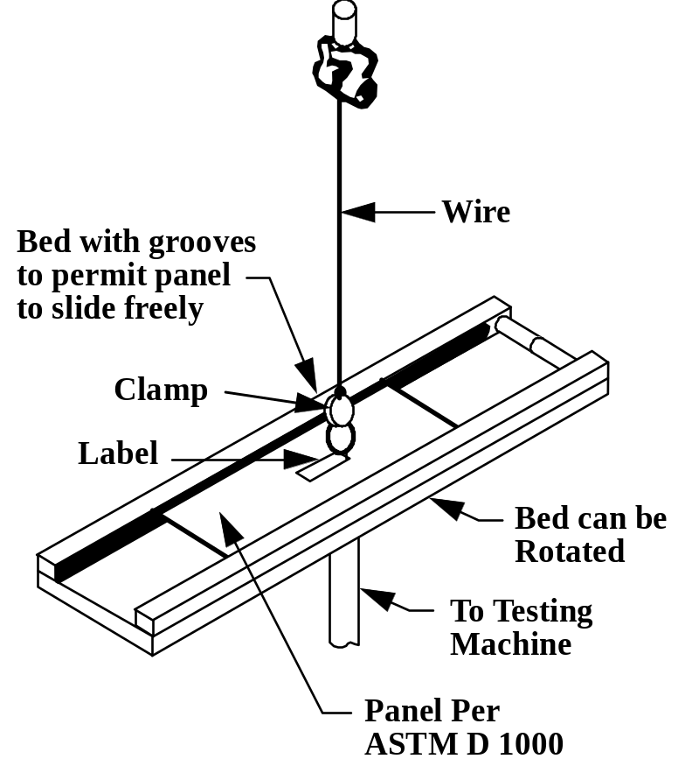

Figure B.1 – Adhesion tester
ANNEX C (NORMATIVE)
TESTING

C.1 TESTING OF TAG UNDER VARIOUS ENVIRONMENTAL CONDITIONS

The tag shall function correctly during and after each of the following tests:

Low temperature – IEC 60068-2 (MIL-STD-810 Method 502.2); minimum temperature of -50ºC.

High temperature – IEC 60068-2 (MIL-STD-810 Method 501.2, Procedure II); cycled between +70ºC and +38ºC, temperatures specified in 4.6.1.

Mechanical shock – IEC 60068-2 (MIL-STD-810 Method 615.3, Procedure I); 30g for 11 ms, half-sine pulse.

Random vibration – IEC 60068-2 (MIL-STD-810 Method 520.0, Procedure II); 2 hour duration, axis up to 3g at -50ºC, ambient, and +70ºC ambient.

Humidity – IEC 60068-2 (MIL-STD-810 Method 507.2); 95% non-condensing.

Rain – IEC 60068-2 (MIL-STD-810 Method 506.1, Procedure II).

Salt fog – IEC 60068-2 (MIL-STD-810 Method 509.2, Procedure I).

Drop shock – IEC 60068-2 (MIL-STD-810 Method 516.3, Procedure II); height 3.3 m, impact surface 5 cm plywood backed with concrete.

Sand and dust – IEC 60068-2 (MIL-STD-810 Method 510.2).

Electromagnetic environment – The tag shall survive and maintain the integrity of stored data in a maximum peak field strength of 50 V/m for 60 s.

C.2 TESTING OF READING EQUIPMENT

The testing of reading equipment shall be agreed between the user and the supplier.

C.3 TESING OF THE COMPLETE SYSTEM

Testing of the combined system requirements shall be carried out to prove the ability of the system to function properly under normal operating conditions at locations where the system is intended to operate.
- Normal operating conditions include the following:
- Temperature: between -50ºC and +70ºC;
- Humidity: up to 100% condensing;
- Random vibration: frequencies as specified in IEC 68.2 (Mil. Std. 810D Method 520.0, Procedure II) at amplitudes up to 0.29g.

ANNEX D (NORMATIVE)
EXAMPLES

D.1 LABEL EXAMPLES

The following shows examples of labels that may include an RFID tag.

D.1.1 Ship to (Optional)

The “Ship to” data element refers to the address of the party to which items are to be delivered. When used, it shall be represented in a maximum of five lines of human readable characters comprised of no more than 35 alphanumeric (an..35) characters each. Figure D.1 shows the layout of a possible label using “J” ANSI MH10.8.2 Data Identifier license plate and additional trading partner data in 2D symbols.

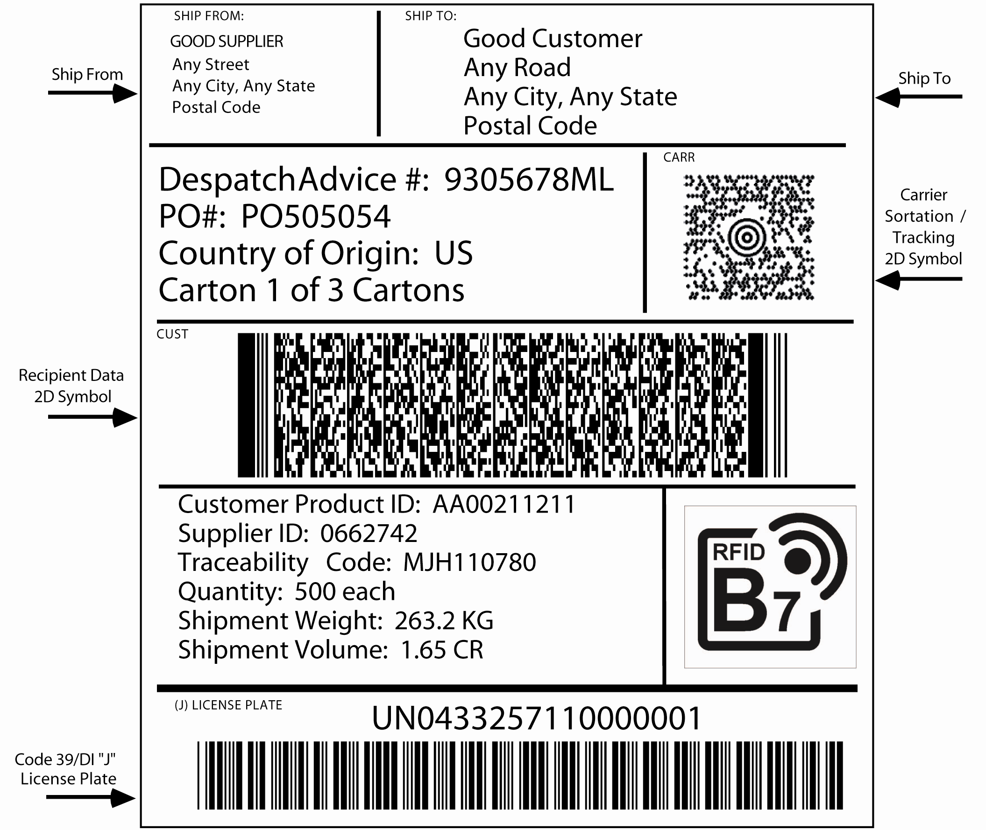

Figure D.1 – Label using “J” ANSI MH10.8.2 Data Identifier license plate
and additional trading partner data in 2D symbols (not to scale)

ANNEX E (INFORMATIVE)
RECOMMENDED LABEL LOCATIONS ON VARIOUS CONTAINERS

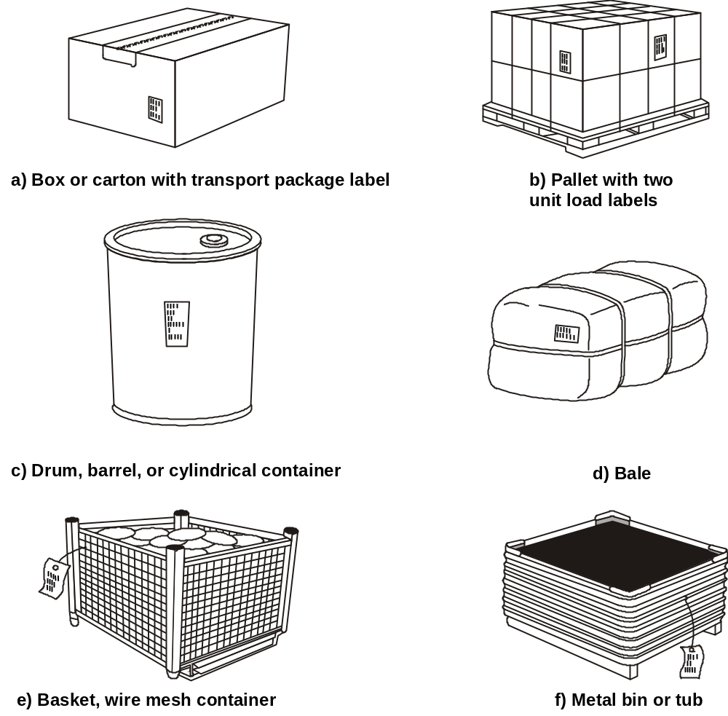

Figure E.1 – Label placement on various packages

